Working with GMNS Files in QGIS and NeXTA

Prepared by Dr. Xuesong (Simon) Zhou’ research group at Arizona State University

Contact: xzhou74@asu.edu

Table of Contents

Part I: Basic Understanding of GMNS and visualization

1. Introduction of GMNS, AMS, QGIS and NeXTA

2. Import GMNS file with geometry field in QGIS

3. Load XYZ Tiles in QGIS with background maps

4. Visualize output file link_performance.csv in QGIS

5. View/edit GMNS network in NeXTA

6. Load GMNS network with background image in NeXTA through the help of QGIS

Part II: Advanced Topics: Create GMNS Networks

7. Create a GMNS Network in NeXTA without background image

8. Create a Network in NeXTA from the background map image

10. How to use NEXTA to visualize the trajectory

# Part I: Basic Understanding of GMNS and visualization

## 1. Introduction of GMNS, AMS, QGIS and NeXTA

**What is GMNS?**

General Travel Network Format Specification is a product of Zephyr Foundation, which aims to advance the field through flexible and efficient support, education, guidance, encouragement, and incubation. <https://zephyrtransport.org/projects/2-network-standard-and-tools/>

**What is AMS?**

As stated in FHWA website, <https://cms7.fhwa.dot.gov/research/operations/analysis-modeling-simulation/analysis-modeling-simulation-overview>, FHWA and its State and local agency partners have relied on analysis, modeling, and simulation (AMS) to support investment decisions for the transportation system. As the transportation system environment grows in complexity, increasing pressure is placed on agencies to identify more innovative and efficient solutions to a wide range of issues. These solutions include leveraging emerging technologies, data sources, and alternative (non-traditional) strategies. AMS tools will continue to play a critical role in evaluating these solutions.

**What is QGIS?**

QGIS is a free and open-source cross-platform desktop geographic information system (GIS) application that supports viewing, editing, and analysis of geospatial data.

QGIS functions as geographic information system (GIS) software, allowing users to analyze and edit spatial information, in addition to composing and exporting graphical maps.

QGIS supports both [raster](https://en.wikipedia.org/wiki/Raster_graphics) and [vector](https://en.wikipedia.org/wiki/Vector_graphics) layers; vector data is stored as either point, line, or [polygon](https://en.wikipedia.org/wiki/Polygon_(computer_graphics)) features. Multiple formats of raster images are supported, and the software can georeference images.

**Source:** <https://en.wikipedia.org/wiki/QGIS>

**What is NEXTA?**

NeXTA: Network explorer for Traffic Analysis

In general, the software suite of NeXTA aims to:

(1) Provide an open-source code base to enable transportation researchers and software developers to expand its range of capabilities to various traffic management application.

(2) Present results to other users by visualizing **time-varying traffic flow dynamics** and traveler route choice behavior in an integrated environment.

(3) Provide a free, educational tool for students to understand the complex decision-making process in **transportation planning and optimization** processes

(4) By managing GMNS data sets in both QGIS and NeXTA platforms, users can visualize the background GIS map for a GMNS network, in a broader spatial context, while NeXTA can provide time-dependent link performance visualization, path-level and agent-level analysis, and time-dependent agent trajectory visualization.

This document describes the process of obtaining [node.csv, link.csv, etc] GMNS-compatible files for use in QGIS from an OSM network and how to display GMNS file including node.csv, link.csv, timing.csv, agent.csv and link_performance.csv in NeXTA.

## 2. Import GMNS file with geometry field in QGIS

Open GMNS node.csv and link.csv in Excel to verify the existence of the geometry field.

Open QGIS and click on menu Layer->Add Layer->Add Delimited Text Layer. In the following dialogue box, load GMNS node.csv and link.csv, and ensure WKT is selected as geometry definition. Sample data set: <https://github.com/asu-trans-ai-lab/NeXTA-QGIS_for_AMS_GMNS/tree/gh-pages/release>

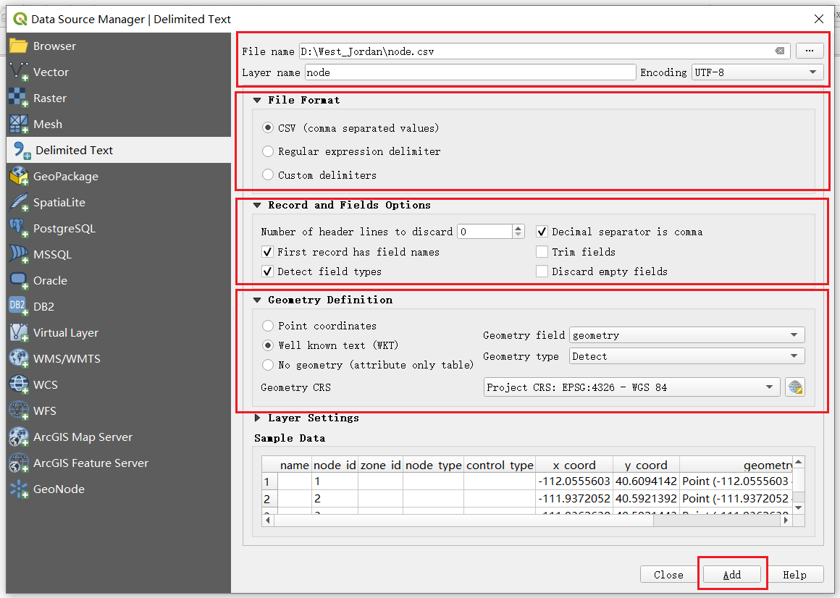

## 3. Load XYZ Tiles in QGIS with background maps

Find XYZ Tiles and double-click OpenStreetMap on Browser panel. Please move the background layer to the bottom to show the GMNS network.

Refence: <https://gis.stackexchange.com/questions/20191/adding-basemaps-from-google-or-bing-in-qgis>

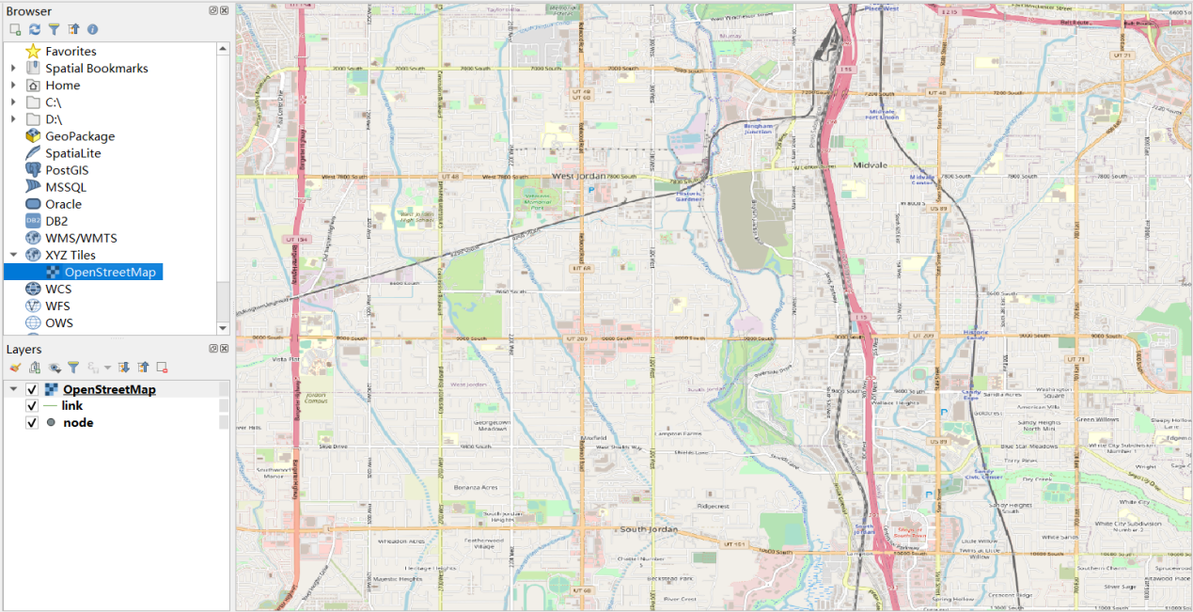

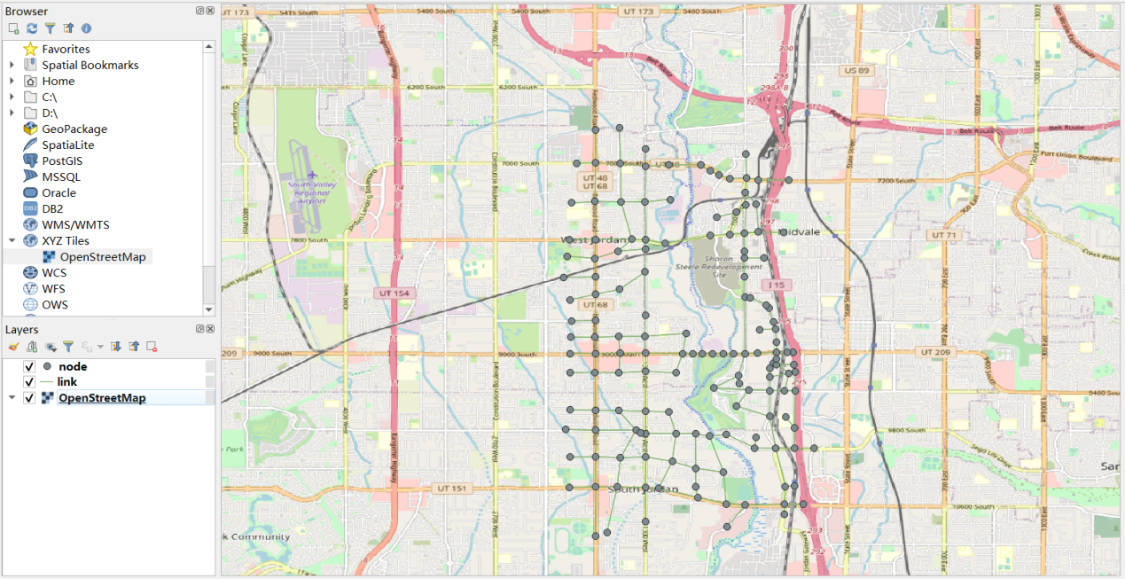

## 4. Visualize output file link.csv in QGIS

The 'geometry' field can be obtained from link.csv file. Then open this file in the same way as above. (Layer->Add Layer->Add Delimited Text Layer)

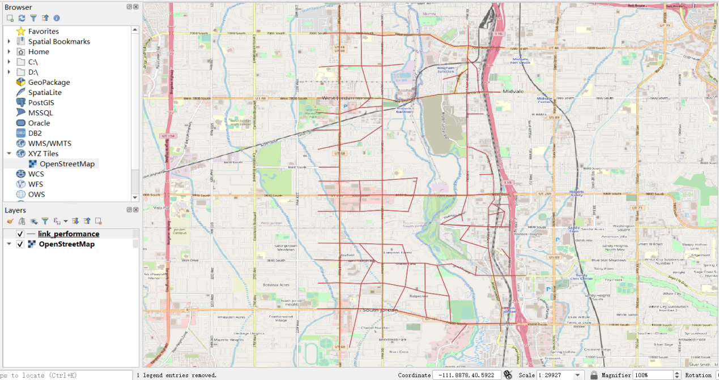

Then you can show the width of links by field VOC with different color according level of VOC in link layer. Right click on link layer and click on properties->control feature->symbology



. Select Graduated->Value: VOC->MethodSize->Classes: ->Classify and set the value of the VOC level.

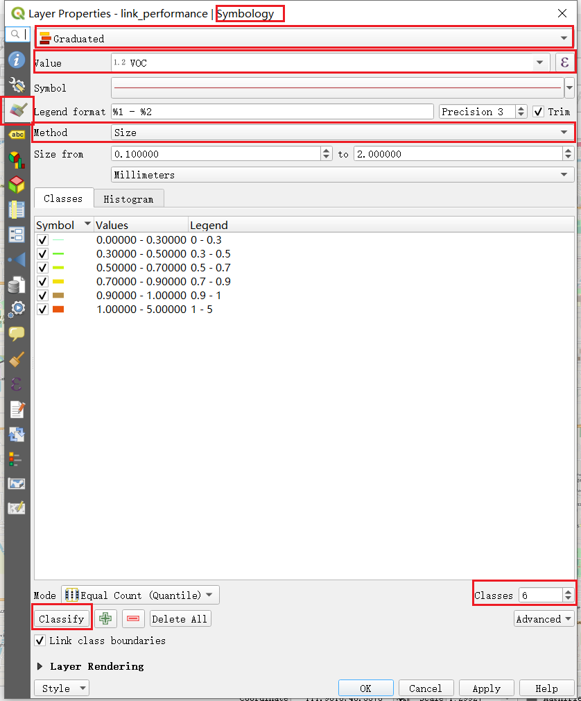

Note that, you can set color and width according to VOC field of each level.

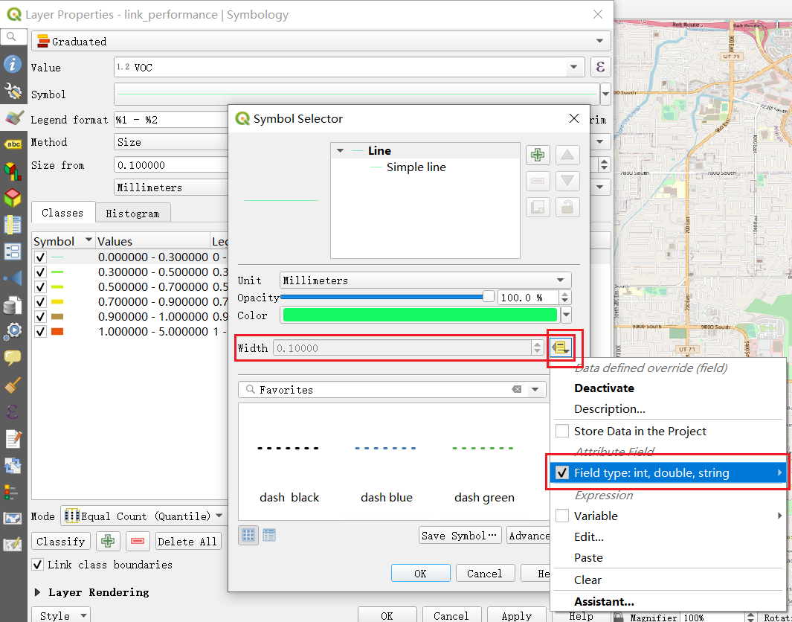

Then you can display traffic assignment result with following picture.

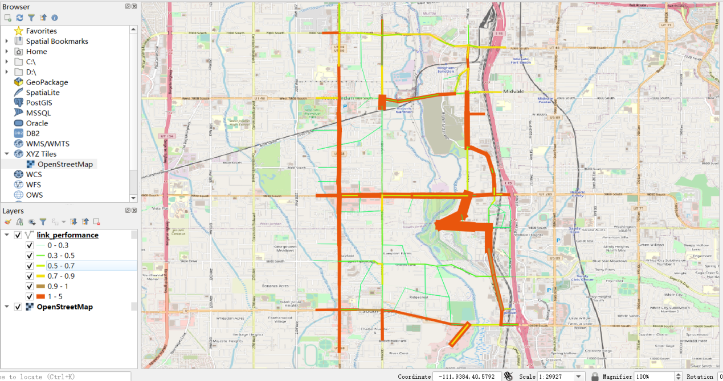

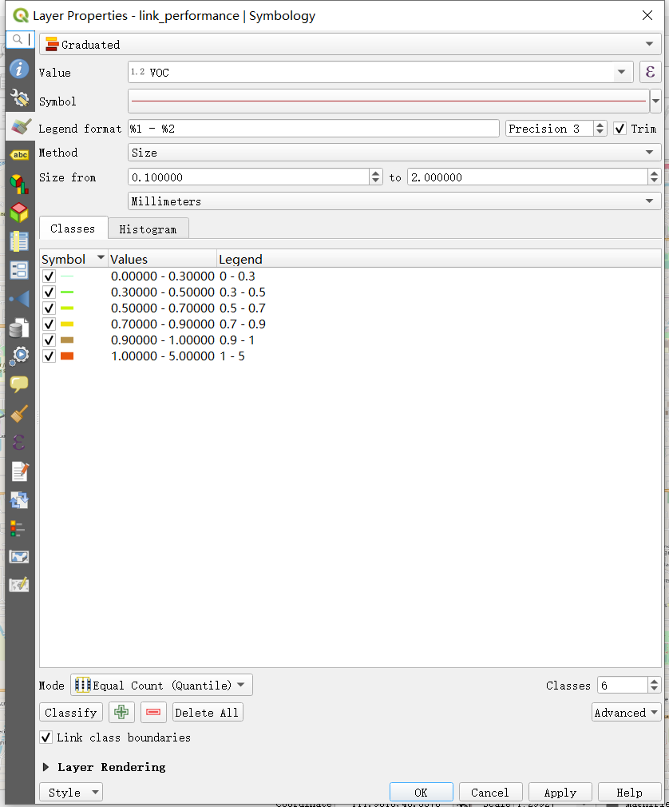

## 5. View/edit GMNS network in NeXTA

Step 1: Download and Open NeXTA, Open the Tempe ASU Network

Before going into too much detail, first makes sure you’re using the most up-to-date version of NeXTA, and open the Tempe ASU network.

Step 2: Open the Tempe ASU Network in NeXTA

In NeXTA, go to File -> Open Traffic Network Project

In the Lesson 1, go to a select GMNS data folder, select the **node.csv** file, and click **Open** (you need to ignore a number of warning messages reported by NeXTA due to missing values)

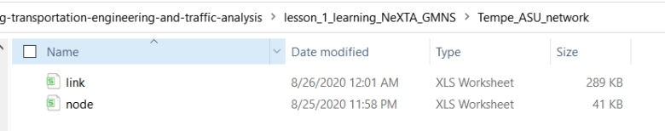

NeXTA will open the network, and display the **File Loading Status window**. The File Loading Status window displays information about the network currently open in NeXTA, including information about the number of links, nodes, and zones/activity locations in the network. This window can also be accessed by going to **File -> Check Data Loading Status**.

Step 3: Viewing/Editing Network Attributes in NeXTA

Network objects primarily consist of links, nodes, and zones. A driver starts and ends their trip at a zone, traveling along road segments (links) between the origin and destination. Links are connected together at nodes, where a node may represent an intersection or a simple connection between two road segments.

Since vehicles only travel along links, passing nodes between their origin and destination, trip details (such as travel time, distance, speed, etc.) are heavily dependent upon link and node attributes. The most important link attributes are typically link length, speed limit, number of lanes, and capacity. Since nodes typically represent intersections, their important attributes typically include node control type (signalized intersection, stop-controlled intersection, no control, etc.) and traffic signal-related attributes.

This section will quickly explain how to view and edit these network object attributes.

**Step 3.1:** To quickly view most link or node attributes, simply select a link or node using the Select Object tool, and look at the attributes in the GIS Layer Panel in the bottom right corner of the screen.

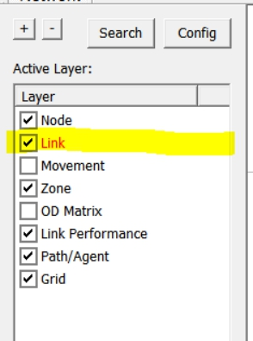

**Step 3.2:** Select link layer as highlighted above.

**Step 3.3:** Select a link along Rural Road as shown below,

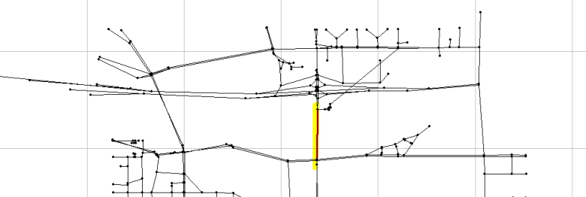

Check the Link Attribute display on the left hand size as shown below.

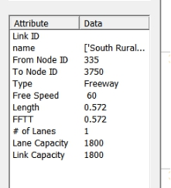

One can now select the node layer in the GIS Layer Panel,

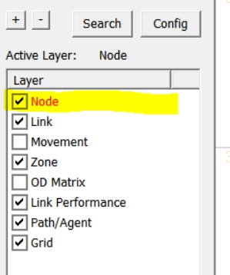

**Step 3.4:** Select a node close to ASU campus,

Check the Node Attribute display on the left-hand size as shown below.

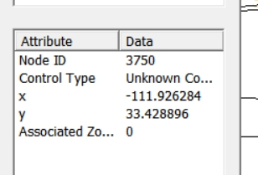

Alternatively, after selecting the link or node, **right-click** near the object and select either Edit Link Properties or Node Properties. Selecting Edit Link Properties opens the Link Properties dialog box, shown below. These dialog boxes offer the ability to edit individual link and node attributes quickly and easily

* simply replace the text/values in the appropriate field, select OK, and click the Save button



on the Tool Bar to save your changes to the network.

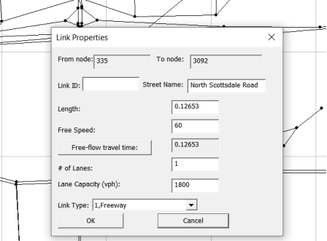

Step 4: Find short paths and use path analysis tool in NeXTA

The Path Analysis Tool is enabled by using the



button or going to MOE > Path List Dialog, which is used to view link attributes and path travel time statistics.

To use the tool, a path must first be selecting in the path layer as shown below.

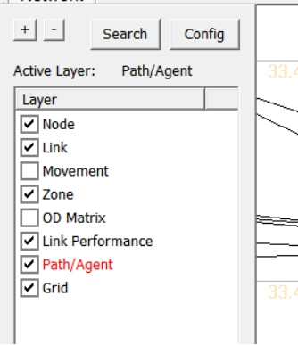

As a recap, this is accomplished by right-clicking the mouse at the origin node for the path, selecting “Direction from Here”, and then right-clicking again at the destination, selecting “Direction to Here”. The path is chosen automatically based on the shortest path between the two points.

Selecting the



button opens the Path Information window, as shown in the example below. Similar to the Link Information window, this tool shows link attributes for the links in the path.

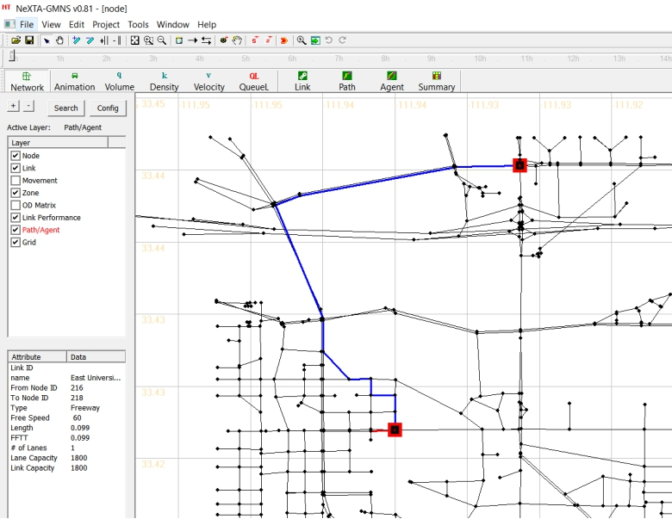

## 6. Load GMNS network with background image in NeXTA through the help of QGIS

Open base map in QGIS

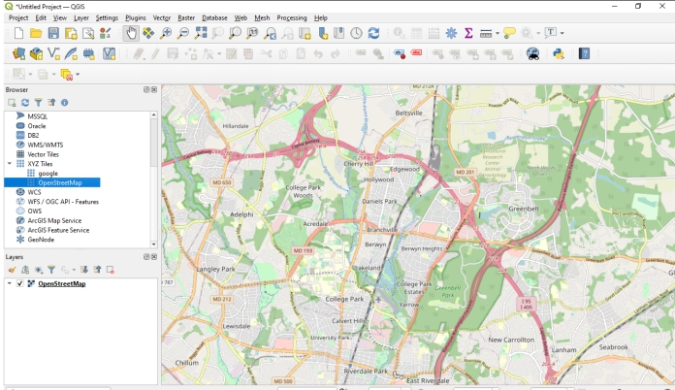

Load GMNS network CSV file in QGIS

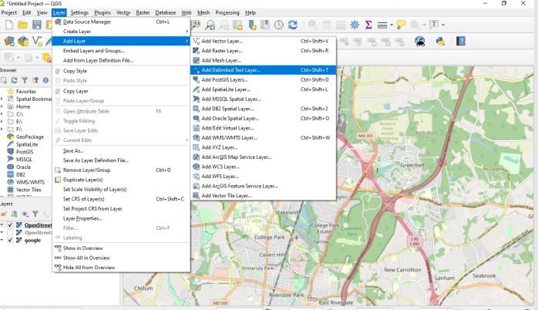

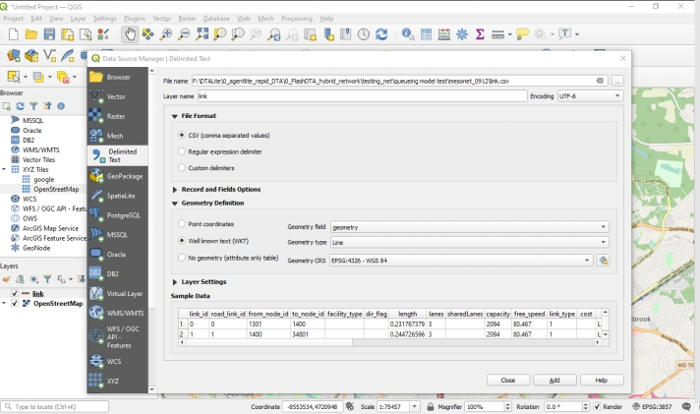

Arrange the order of QGIS layers so that the background images are shown below the network layer.

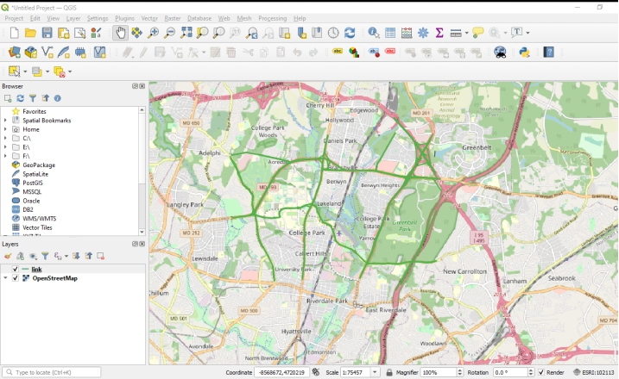

Choose the proper area and export the map as image by clicking on menu Project->Import/Export/Export Map to Image

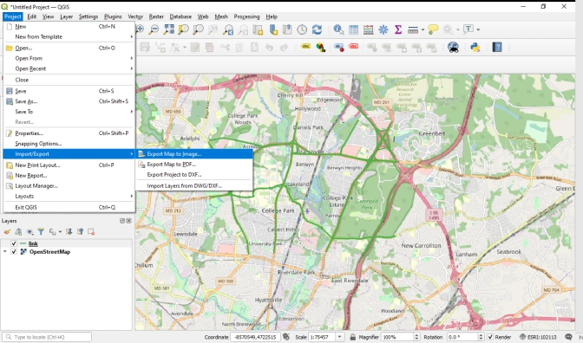

Choose the proper network resolution, size of image, and please also select lock the aspect ratio.

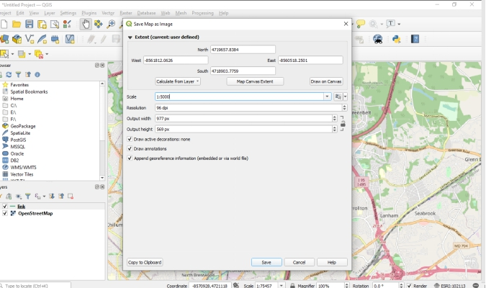

Save it as .bmp format image and the same folder of the DTALite/NeXTA project.

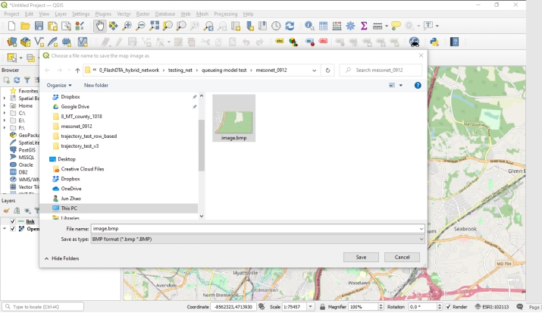

Open node.csv within NeXTA directly, and the background map will be loaded automatically.

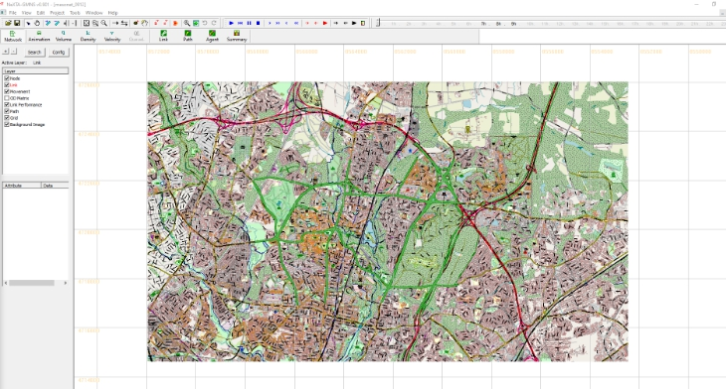

# Part II: Advanced Topics: Create GMNS Networks

## 7. Create a GMNS Network in NeXTA without background image

Step 1: Open NeXTA

open NeXTA.exe

Step 2: Add new one-way links

Related toolbar buttons:



Step 2.1: Press the “Link”



toggle button.

Step 2.2: Press the left mouse on the location you want the link to start. This could be on an existing node or where no node currently exists. Move the cursor to the desired end of the link. Now release the left mouse on the location you want the link to end. Again, this can be on a node or not. A link will be created between these two locations, as shown below:

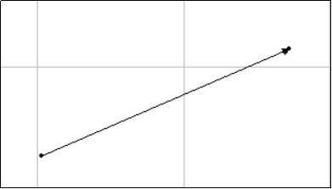

Step 3: Add multiple connected links

Related toolbar buttons:



,



Step 3.1: Press the “Link”



toggle button.

Step 3.2: Add an one-way link according to Step2.

Step 3.3: Press the left mouse on the location you want the link to start and (carefully) release your mouse on the location you want the link to end (or on an existing node if you want to connect to another link). A set of links will be created between these two locations as, as shown below:

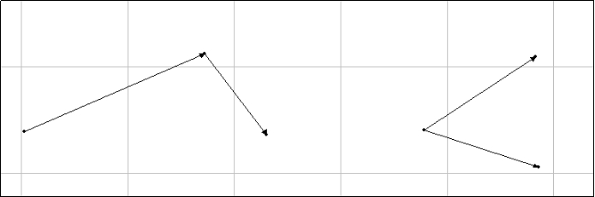

Step 3.4: To increase the overlapping range for detecting if links are overlapping, you can click on the  toggle button continuously on the top of the GIS layer panel to enlarge the node display area first. It is obvious that the link (1,2) is connected with link(2,3), as shown below:

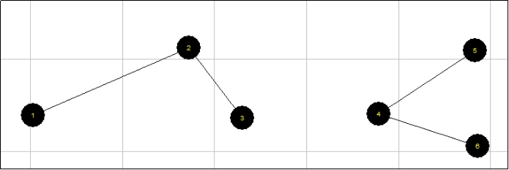

Adjust node size for display

Related toolbar buttons:



Press the  toggle button and adjust node size, as shown below:

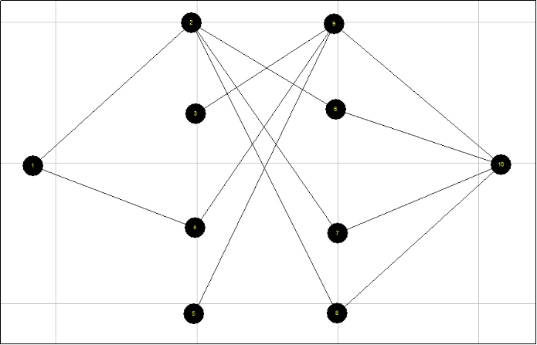

Save GMNS data of node and link csv files

Related toolbar buttons: 

Click the “save”  toggle button and to save the files of “node.csv” and “link.csv” to the local project folder.

## 8. Conversion between SHAPE file and CSV file

Shape files are commonly used in different GIS and transportation planning tools.

Two-way conversion allows users to easily use Excel to edit field names and field values, e.g. using VLOOKUP functions to batch-process the values based on link attributes, and then GIS to display the network geometry in a standard way.

The tools used in this user guide is summarized below.

Table Tools used in this user guide

|  |  |  |
| --- | --- | --- |
| Number | Tool | Address or format |
| 1 | Nexta | \releases |
| 2 | Excel |  |
| 4 | QGIS/ArcGIS |  |
| 5 | CSV files | node.csv, link.csv |
| 6 | Shape files | *.dbf, *.shp, *.shx The shapefile format is a geospatial vector data format for geographic information system (GIS) software. It is developed and regulated by Esri as a mostly open specification for data interoperability among Esri and other GIS software products. https://en.m.wikipedia.org/wiki/Shapefile |

## How to use NEXTA to visualize the trajectory in space time diagram

NGSIM data set

<https://ops.fhwa.dot.gov/trafficanalysistools/ngsim.htm>

|  |  |  |
| --- | --- | --- |
| Category | File | Remark |
| Main program | NEXTA_4_Trajectory.exe | Open source NEXTA visualization tool |
| Input | trajectories-0400-0415 | Sample file from NGSIM |
| Input | test_one_linetest_two_lines | Sample file from Pan Shang, for one vehicle&#39;s trajectory |
| Output | Trajectory.csv | Export to more user readable format |

**Format**

Each line is a record of trajectory

Please use space or comma to separate fields.

|  |  |  |  |  |  |
| --- | --- | --- | --- | --- | --- |
| No | Field Name | Example 1 | Example 2 | Unit | Remark |
| 1 | Vehicle_ID | 1 | 1 |  |  |
| 2 | Frame_ID | 12 | 13 | 0.1 seconds |  |
| 3 | Total_Frames | 884 | 884 | 0.1 seconds |  |
| 4 | Global_Time | 1113433136100 | 1113433136200 | text | you can put any value |
| 5 | Local_X | 16.884 | 16.938 |  | not used |
| 6 | Local_Y | 48.213 | 49.463 | feet |  |
| 7 | Global_X | 6042842.116 | 6042842.012 |  | not used |
| 8 | Global_Y | 2133117.662 | 2133118.909 |  | not used |
| 9 | Vehicle_Length | 14.3 | 14.3 | feet |  |
| 10 | Vehicle_Width | 6.4 | 6.4 | feet |  |
| 11 | Vehicle_Class | 2 | 2 |  | pax or truck |
| 12 | Vehicle_Velocity | 12.5 | 12.5 |  |  |
| 13 | Vehicle_Acceleration | 0 | 0 |  |  |
| 14 | Lane_Identification | 2 | 2 |  | very important |
| 15 | Preceding_Vehicle | 0 | 0 |  |  |
| 16 | Following_Vehicle | 0 | 0 |  |  |
| 17 | Spacing | 0 | 0 |  |  |
| 18 | Headway | 0 | 0 |  |  |

**Steps**

Step 1: Open the customized NEXTA from this folder.

https://github.com/asu-trans-ai-lab/NeXTA4GMNS/tree/gh-pages/2Dtrajectory_visulization

<https://github.com/asu-trans-ai-lab/NeXTA4GMNS/blob/gh-pages/2Dtrajectory_visulization/NeXTA4_Trajectory_package.zip>

![](https://github.com/xzhou99/NeXTA_4_Trajectory_Visualization/blob/master/1.PNG)

Step 2: Select menu Tools-NGSIM Tools- **Active Space-Time View, and then load** trajectory file for Visualizing trajectory data

Step 3:

![](https://github.com/xzhou99/NeXTA_4_Trajectory_Visualization/blob/master/3.PNG)

Main functions

1. **Display trajectories for each lane.**

![](https://github.com/xzhou99/NeXTA_4_Trajectory_Visualization/blob/master/4.PNG)

In the menu Tools-NASIM Tools:

![](https://github.com/xzhou99/NeXTA_4_Trajectory_Visualization/blob/master/4.PNG)

You can choose each lane number to see the trajectory;

![](https://github.com/xzhou99/NeXTA_4_Trajectory_Visualization/blob/master/5.PNG)

1. You can show Vehicle ID, and you can use mouse wheeler to zoom in and zoom out the display in the certain portion.
2. You can use the mouse to click and draw a line in the space-time plate, and the NeXTA will automatically calculate the flow, density, and speed values across the line

![](https://github.com/xzhou99/NeXTA_4_Trajectory_Visualization/blob/master/6.PNG)

1. You can show cumulative flow count and density

![](https://github.com/xzhou99/NeXTA_4_Trajectory_Visualization/blob/master/7.PNG)

You can show the space-time Density Contour

![](https://github.com/xzhou99/NeXTA_4_Trajectory_Visualization/blob/master/8.PNG)